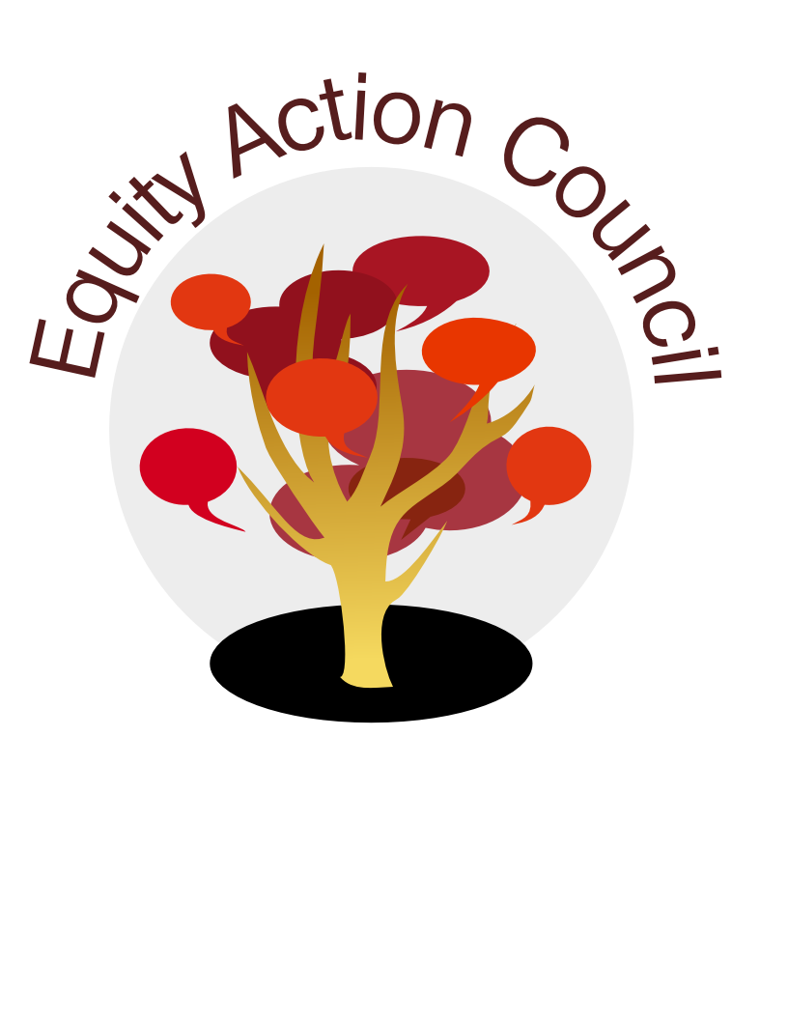
Equity Action Council Agenda: 4/27/16
Time | Topic | Process | Facilitator(s)
2:30 | Welcome/Agenda Review | -Review community agreements and Agenda  - Adriana will lead opening activity  - Veronica’s Status Update (out until fall) | Adriana and Edmundo
3:00 | Equity Praxis: Application in EAC | Presentation and Group Activities | Edmundo/All
4:15 | Next Steps | - How will we practice these commitments in our upcoming meetings? | Anita/All
4:30pm | Closing | -Whip Around appreciation of another person in the room | All
EAC Community Agreements
Show up, and choose to be present
Pay attention to what has heart and meaning
Tell the truth without blame or judgment
Be open to outcome, not attached to outcome
From The Four-Fold Way® by Angeles Arrien, Ph.D.

UPCOMING MEETINGS:
May 11th Quality of Instruction and student perspectives
May 25th Cross Listing: How is this about equity?
June 8th Cancelling due to low enrollment and the impact on part-time faculty
June 22nd EAC Leadership Team Meeting CANCELLED

EAC ANNUAL RETREAT Postponed until FALL!

THANK YOU TO OUR MEMBERS WHO BROUGHT SNACKS THIS WEEK!

