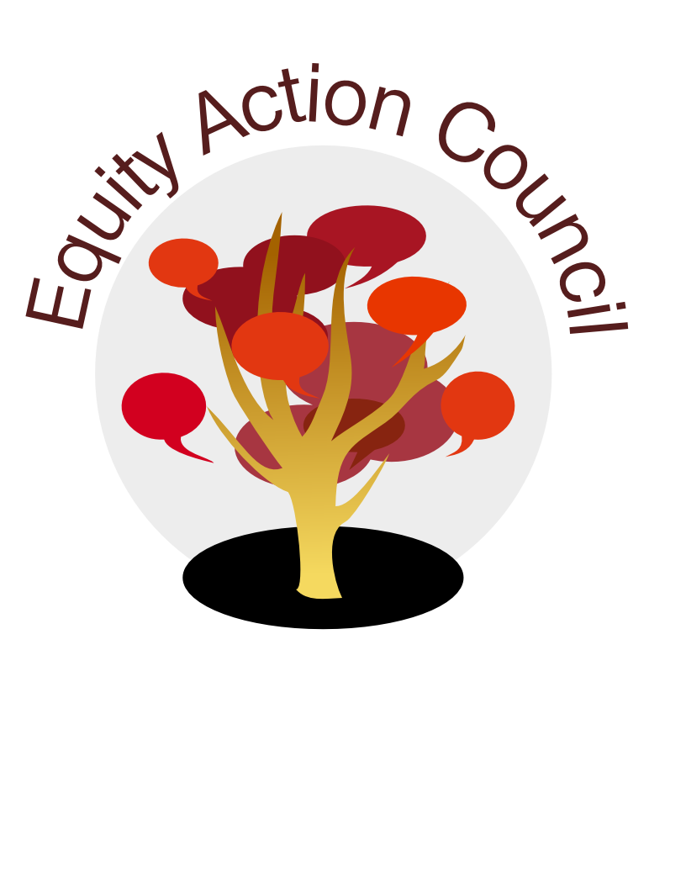
Equity Action Council Agenda: 6/15/2016
Time | Topic | Process | Facilitator(s)
2:30 | Welcome/Agenda Review and Check-in | - Sign In and Welcome
2:40 | Reception | - Equity Champions | Darren?
3:00 |  | - Report backs from committees | All
3:30 | Organizational Planning | - Assessment of EAC 2015-2016  - Protocol...something like...  - present issue to group  - people involved in issue to share perspective  - How decisions get made? Communication gap?
4:00 | Closing | - Announcements  - Calendaring  - Appreciations
4:30 | End | Thank you!
EAC Community Agreements
Show up, and choose to be present
Pay attention to what has heart and meaning
Tell the truth without blame or judgment
Be open to outcome, not attached to outcome
From The Four-Fold Way® by Angeles Arrien, Ph.D.

