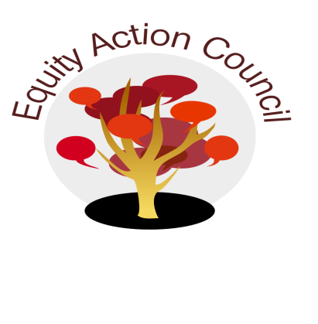
Time | Process | Topic | Facilitator(s)
1:30pm | I | I. Introduction: Welcome and Conocimiento | Melissa Aguilar
1:45pm | I | II. Welcome/Equity Partners - New Faculty Intro/ Liliana Rivera/Amy Wang | Alicia Cortez
1:55pm | I | III. College Council Update | Edmundo Norte
2:05pm | I | IV. Police Chief Advisory Update | Danny Acosta/E. Norte
2:15pm | I/D | V. EAC Retreat Proposal | Alicia Cortez
 |  | VI: College Planning Committee Update after College Council | Alicia Cortez and Tony Santa Ana
2:25pm | I/D | VI: Subcommittee Report:  - DASB/ICC  - Equity Champion Award  - Technology Advisory | Committee Members
2:35pm | I | VII. Announcements | All
2:45pm | I | VIII. Appreciations | All

EAC Community Agreements
Show up, and choose to be present
Pay attention to what has heart and meaning
Tell the truth without blame or judgment
Be open to outcome, not attached to outcome
From The Four-Fold Way® by Angeles Arrien, Ph.D.

