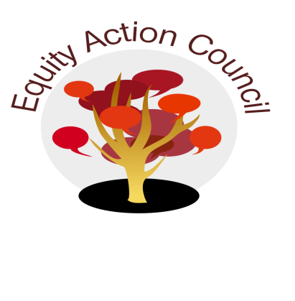
Time | Process | Topic | Facilitator(s)
1:30pm | I | I. Introduction: Welcome and Conocimiento | Adriana Garcia
1:45pm | I | II. Welcome/Equity Partners – ICS Updates | Edmundo Norte
1:55pm | I | III. SB 68 and Undocumented Advisory Committee | Melissa Aguilar + Angelica Esquivel Moreno
2:35pm | I/D | VI: Subcommittee Report:  - DASB/ICC  - Equity Champion Award  - Technology Advisory  - Police Chief Advisory Update | Committee Members
2:45pm | I | VII. Announcements | All
2:55pm | I | VIII. Appreciations | All
EAC Community Agreements
Show up, and choose to be present
Pay attention to what has heart and meaning
Tell the truth without blame or judgment
Be open to outcome, not attached to outcome
From The Four-Fold Way® by Angeles Arrien, Ph.D.

