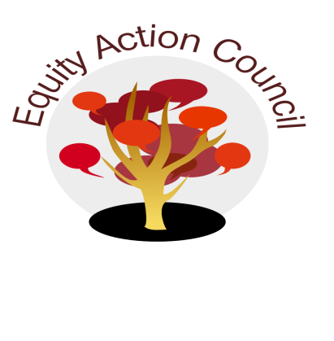
Time | Process | Topic | Facilitator(s)
1:30pm | I | I. Introduction: Welcome and Conocimiento
1:45pm | I | II. DASB Report | DASB Representative
1:50pm | I | III. Welcome Umoja/AAAA - Claudia Barbosa Egbuonye | Alicia Cortez
2:00pm | I | IV. Campus Climate Report | Alicia Cortez
2:05pm | I/D | V. Presidential Search Survey Update – Website Link | Melissa Aguilar
2:15pm | I/D | VI: IPBT Update | Alicia Cortez
2:30pm | D/A | VII. Call for Equity Champion Award Committee | Erick Aragon
2:45pm | I | VII. Announcements | All
2:55pm | I | VIII. Appreciations | All

EAC Community Agreements
Show up, and choose to be present
Pay attention to what has heart and meaning
Tell the truth without blame or judgment
Be open to outcome, not attached to outcome
From The Four-Fold Way® by Angeles Arrien, Ph.D.

