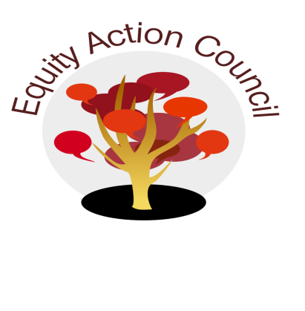
Time | Process | Topic | Facilitator(s)
1:30pm | I | I. Introduction: Welcome and Check in With Participants | Edmundo Norte
1:35pm | I | II. Subcommittee Reports  - DASB/ICC: Report & Student Survey & Voices  - Equity Champion Award  - Technology Update  - Police Chief Advisory | Committee Members
2:10pm | D | III. Shared Governance Survey | Melissa Aguilar
2:15pm | D/A | IV: Review of EAC structure  - How can we be better?  - Numbers: 2 Classified representatives, 2 Faculty, 2 Student  - Terms  - Others Voices, stakeholders  - Summer Retreat | Alicia Cortez
2:35pm | D | V: Shared Governance Reflections | Erick Aragon and Edmundo Norte
2:50pm | I | VI. Announcements  *Equity Champion Awards  *Equity Celebration Part II  *End of Year Celebrations | All
2:55pm | I | VII. Appreciations | All

EAC Community Agreements
Show up, and choose to be present
Pay attention to what has heart and meaning
Tell the truth without blame or judgment
Be open to outcome, not attached to outcome
From The Four-Fold Way® by Angeles Arrien, Ph.D.

