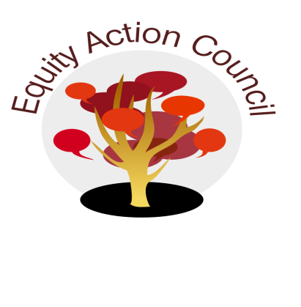
Time | Process | Topic | Facilitator(s)
1:30 | I | I. Introduction: Conocimiento and Check In | Edmundo Norte
1:45 | I/D/A | II. Subcommittee Report:  - DASB/ICC  - Update: Steffani Djuarsa, Anh Doan  - Shared Governance Document for adoption - Rex Zhang  - Equity Champion Award ( Erick Aragon, Hyon Chu Yi-Baker & Adriana Garcia) | Representatives
1:50pm | I | III. Shared Governance Questions | Alicia Cortez
2:00pm | I | IV. AB 705 Presentation | Mallory Newell
2:20pm | I/D/A | V. Campus Climate Survey & Discussion | Mallory Newell & Alicia Cortez
2:50pm | I | VI. Announcements & Appreciations | Melissa Aguilar

EAC Community Agreements
Show up, and choose to be present
Pay attention to what has heart and meaning
Tell the truth without blame or judgment
Be open to outcome, not attached to outcome
From The Four-Fold Way® by Angeles Arrien, Ph.D.

