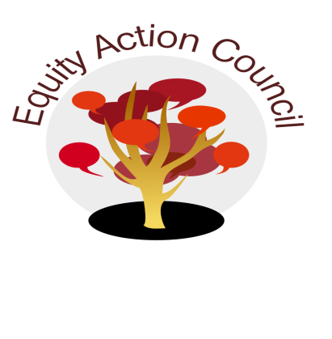
Time | Process | Topic | Facilitator(s)
1:30-1:45pm | I | I. Introduction: Conocimiento and Check In | Edmundo Norte
1:45-1:50pm | I/D/A | II. Subcommittee Report:  - DASB/ICC  - Update: Steffani Djuarsa, Anh Doan  - Shared Governance Document for adoption - Rex Zhang  - Equity Champion Award ( Erick Aragon, Hyon Chu Yi-Baker & Adriana Garcia)  - Technology Advisory (Sandy Cordoza)  - District Book Club: Alicia, Tony, | Representatives
2:00-2:10pm | I | III. Queer & Now Conference Update | Melissa Aguilar
2:10-2:35pm | I | IV. District Diversity and Equity Advisory Committee Report | Alicia Cortez  Edmundo Norte  Erick Aragon
2:35-2:50pm | I/D/A | V. Student Equity Plan Final Document - http://deanza.edu/ir/planning/index.html | Alicia Cortez
2:50-3:00pm | I | VI. Announcements & Appreciations | Erick Aragon

EAC Community Agreements
Show up, and choose to be present
Pay attention to what has heart and meaning
Tell the truth without blame or judgment
Be open to outcome, not attached to outcome
From The Four-Fold Way® by Angeles Arrien, Ph.D.

