Hello all-
As mentioned in the Celebration for Sandra Diaz, a memorial bench will be purchased and placed on campus in the S Quad with funds donated by students, staff, faculty and friends. The plaque will read:

In Memory Of
Sandra Diaz, MSN, RN
Teacher, Mentor, Colleague and Friend

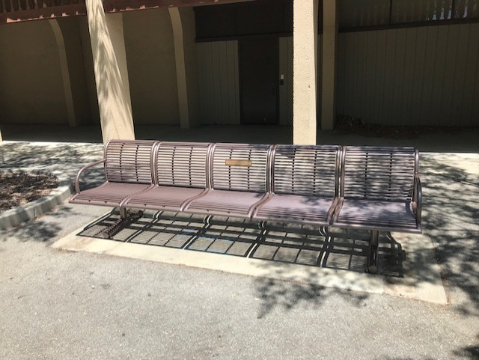

Any additional funds will be directed to a scholarship in her name for nursing students. (Directions on next page)

You can make a donation to the De Anza College Nursing Program for the scholarship in Sandra's name by visiting:

https://secure.donationpay.org/fhda/

Simply type Sandra's name in the "In Memory of" box or designate it for "De Anza Nursing."

