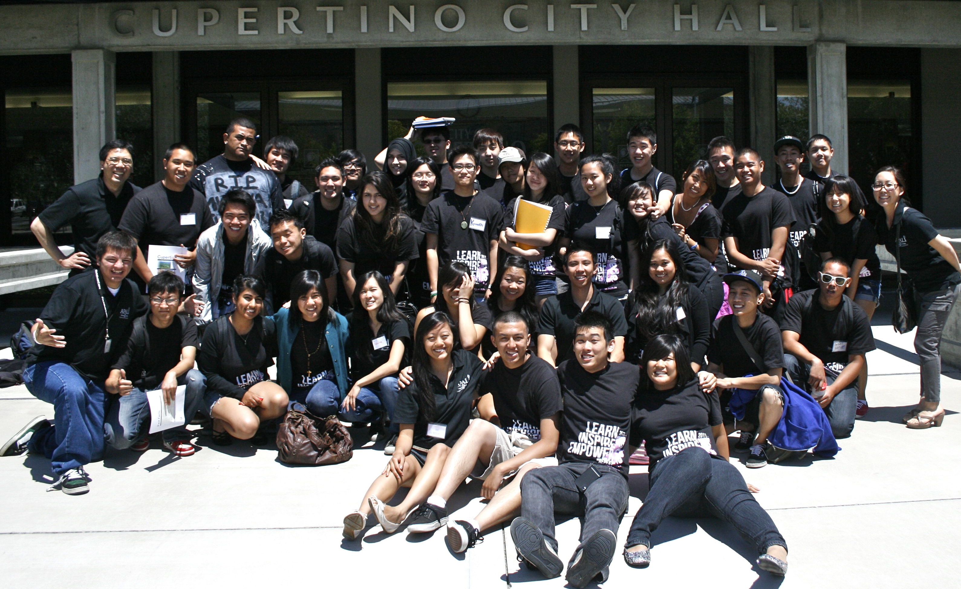
APASL
Asian Pacific American Students for Leadership

Our goal is to promote Asian Pacific American
student empowerment and leadership through community involvement.

APASL Meeting every Thursday
@ MCC Conference Room
12:30 to 1:20 pm

